Report and Analysis of Comparing ACO plots to MMAS and MMAS* approach

To get a robust analysis of the report, I chose functions to represent a diverse range of functions. These are the functions which are selected to draw the analysis and comparison of MMAS / MMAS* approach with ACO plot :- F1, F3, F18 and F23. Our central goal is to evaluate the efficiency, robustness, and balance between exploration and exploitation b/w our own designed ACO algorithm and pre-defined methods.

- F1

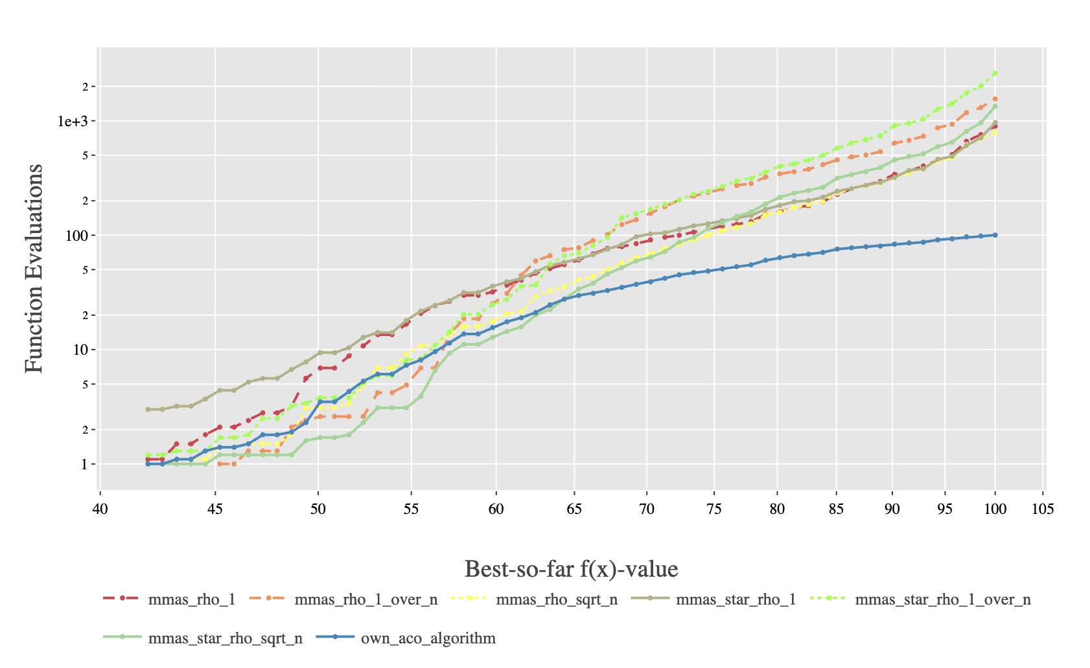

- Better Performance of own_aco_algorithm (Blue Line): The own_aco_algorithm line is clearly positioned lowest on the plot across the entire range of f(x) values (ranging from f(x) = 40 to 100). This indicates that it required the lowest computational cost to achieve any given solution quality.

- Convergence Speed: The blue line exhibits the most efficient convergence path, mostly in the later stages (beyond f(x)=70). For example, to reach an f(x) value of 95, the own_aco_algorithm requires approximately 102 (100) evaluations, while most other MMAS algorithms require close to 103 (1000) evaluations. This represents a significant difference in the efficiency.

- Comparison to MMAS/MMAS*: All variations of the MMAS and MMAS* algorithms cluster together throughout the plot, showing similar performance profiles. They are all significantly less efficient than the proposed own_aco_algorithm. These strong separations suggests the modifications introduced in the own_aco_algorithm are highly effective for exploitation tasks.

Conclusion for F1

The results for F1 confirm that the own_aco_algorithm possesses higher exploitation capabilities compared to the tested MMAS and MMAS* variants in exercise 4. The mechanism involved with pheromone update, evaporation rate, and selection strategy appears to guide the search more accurately towards the global optimum on smooth landscapes, resulting in significantly faster convergence.

- F3

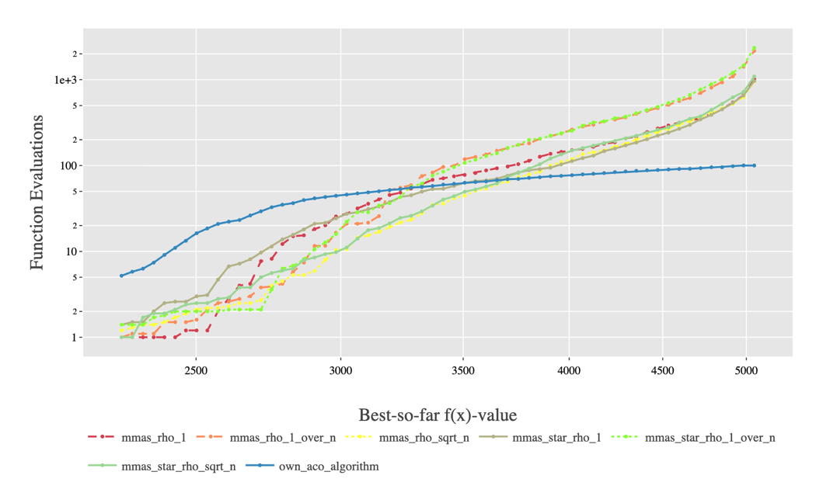

- Dominant Performance of own_aco_algorithm (Blue Line): Consistent with the analysis of function F1, the own_aco_algorithm maintains the lead in terms of efficiency. Its line is positioned clearly at the bottom of the graph, indicating that it requires the minimum number of Function Evaluations to reach any given solution quality.

- Early Stage Efficiency: The proposed algorithm achieves its initial fitness gains (up to f(x)≈3000) faster than any other variant, suggesting its pheromone initialization highly effective at identifying the most valuable bits early in the search.

- Late Stage Precision: The performance gap between the own_aco_algorithm and the MMAS variants widens significantly in the later stages (beyond f(x)=4000). To reach the highest solution qualities (approaching f(x)=5000), the standard MMAS variants experience a hike where the number of required Function Evaluations increases. On the other hand, the blue line remains flat, indicating its ability to efficiently resolve the final bits without stagnation.

Conclusion for F3
The results on F3 reinforce the findings from F1, confirming the higher exploitation efficiency of the designed own_aco_algorithm. This approach appears particularly well-suited for solving highly weighted or ranked problems, as it avoids the stagnation seen in the standard MMAS variants when attempting to customize the solution by increasing the lower weighted bits. The algorithm well manages its pheromone distribution to prioritize the heavy components of the solution.

- F18
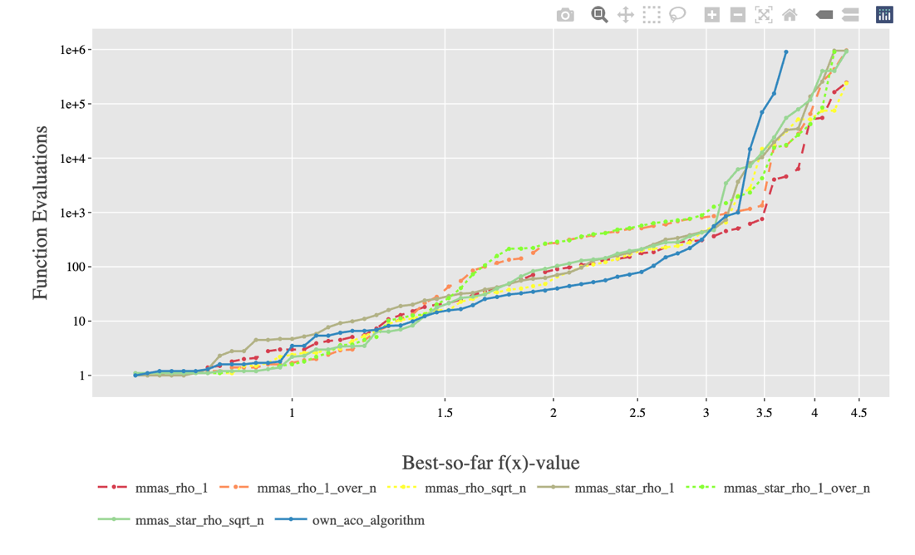

- Early Stage Exploration: In the initial phase (f(x) = 1.5), performance is mixed, and no single algorithm immediately dominates, all of them increases. The initial cluster of lines shows that the exploration strategies of all MMAS and the own_aco_algorithm are comparable.

- Mid Stage Separation and Efficiency: Beyond f(x) = 2, the own_aco_algorithm (Blue Line) begins to demonstrate superior efficiency, demonstrating the robustness of the algorithm. It continues its increase to f(x)=3 by requiring fewer Function Evaluations than the majority of the other MMAS and MMAS* variants, which start to plateau or require steep increases in cost (Y axis) to achieve small gains.

- Handling Extreme Ruggedness (Late Stage):

- The standard MMAS and MMAS* algorithms hit a step increase in performance, requiring an exponential jump in Function Evaluations (from 103 up to 106) to achieve the highest fitness values (f(x) = 4.0 and above). This indicates they are having a hard time with stagnation and achieving local optima.
- In contrast, the own_aco_algorithm demonstrates stability in growth. Although, it also requires a sharp increase in cost, this increase occurs later and less steeply than for the other variants. It maintains the lowest plot (blue) among all algorithms as it approaches the highest fitness values shown, confirming it is the most effective at escaping the unexpected traffic.

Conclusion for F18
The F18 analysis highlights the superior exploration capability and long-term robustness of the own_aco_algorithm. On this complex landscape, the modifications in the proposed algorithm are highly effective at preventing prior convergence and efficiently navigating the local optima. The ability of the blue line to stay consistently lower in the late stages confirms that its combination of exploration and pheromone management is better suited for challenging, non linear problems than the standard MMAS approaches tested in exercise 4.

- F23
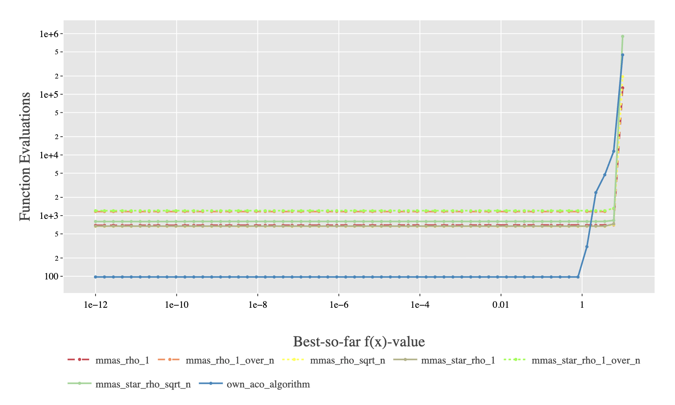

- Exploitation Dominance: The own_aco_algorithm (Blue Line) shows dominance in the early and middle stages of the search. It consistently operates at a cost of only 100 Function Evaluations, while all MMAS and MMAS* variants operate an order of magnitude higher, clustered around 103 (approx.) function evaluations.

- Critical Breakthrough Point: All algorithms exhibit a sharp, vertical spike in Function Evaluations as moved from a very high quality solution to the final optimal solution. This vertical climb represents the immediate computational cost required to make the final adjustments needed to satisfy the last remaining constraint.

- Efficiency to Reach Optimum: Even at the final breakthrough point, the own_aco_algorithm is the most efficient. It reaches the final solution while staying at a threshold, whereas the worst performing MMAS variant (the red dashed line) require more evaluations. This confirms its efficiency advantage persists even when extreme precision is required.

- MMAS Stagnation: The standard MMAS and MMAS* variants demonstrate a long, flat plateau between f(x) = 10*−12 and f(x) = 10*−1 at a constant cost of 103 evaluations. This indicates they spend a large amount of time stagnating near the true solution before they can build enough pheromone. The own_aco_algorithm does not show this severe plateau, allowing it to quickly build up the solution quality.

Conclusion for F23
The performance on F23 demonstrates that the own_aco_algorithm is exceptionally well for highly constrained, precision problems. It’s unique pheromone update and selection mechanism allows it to efficiently build the large scale structure of the solution and then make the final transition to the perfect optimum with lower computational costs as compared to its counterparts.

